Framework for Entry to Practice Supervision by
Physiotherapy Regulators in Canada
FINAL
December 16, 2014

Background:

A literature review commissioned by The Canadian Alliance of Physiotherapy Regulators’ (The Alliance) Registrars’ Committee identified a number of specific needs/issues associated with each of three target groups that are candidates for supervised practice. 1) For new graduates, the transition from training to practice can lead to feelings of stress, insecurity and potential safety issues. This period also involves a number of important stages necessary for the development of the professional; 2) Internationally educated health professionals (IEHPs), entering the workforce also experience challenges including: language/communication and differences in practices (e.g., technology, autonomy, accountability and scope) that can affect professional relationships and potentially patient safety; and 3) Re-entry candidates have special issues/needs when they return to work that include feelings of anxiety and low self-esteem, as well as a desire for flexible programs. In terms of best practices in entry level supervision, programs involving role models and mentors can play an important role in facilitating entry or re-entry to practice and a shift towards more structured transition programs for new graduates and internationally educated health professionals was noted. Consistency through an evidence-informed framework is needed to help each group succeed in professional practice.

Purpose:

The purpose of entry to practice supervision in physiotherapy is to protect the public during a period of temporary licensure when a registrant has not met all of the requirements for independent practice.

The purpose of this Framework for a Harmonized Approach to Entry to Practice Supervision by Physiotherapy Regulators in Canada (Framework) is to:
- Set out evidence-informed best practice regarding the supervision of physiotherapists on temporary licenses that can serve as a model of regulatory requirements across the country;
- promote consistency and best practices in entry to practice supervision approaches throughout Canada without guaranteeing sameness;
- support labour mobility across jurisdictions in Canada;
- clarify practice expectations and requirements for newly-registered physiotherapists, be it Canadian, or internationally-trained.

Scope:

This Framework and its principles serve as a guide for all entry-to-practice supervisory relationships for all physiotherapy regulatory Colleges in Canada. The Supervisory relationships apply primarily to first-time physiotherapists, either Canadian- or internationally-trained.

The scope of this framework is limited to the supervision of physiotherapists on temporary licenses and does not include best practices for mentorship.

Terminology

The term “supervision” is used in this Framework to refer generally to the relationship that is established between a more experienced physiotherapist and an entry to practice physiotherapist who has met the first stage of requirements for registration, but has not met all the requirements for full registration (independent practice) to ensure the protection of the public. Similarly, the terms “supervisor” and “supervisee” are used generically to describe the two participants in the supportive relationship.

For the purposes of this framework, the terms “applicant” and “supervisee” will be used interchangeably.

Principles:

The Framework is based on the following core principles:
- Evidence based: This Framework has been informed by best practices for supervision identified through review of relevant literature, an environmental scan including review of practice in other professions, as well as expert key-informant opinion;
- Flexibility: The Framework recognizes the need for a flexible approach within a “gold standard” that considers the variations in regulatory contexts across the country, as well as the different experiences and needs of the individuals being supervised. As such the guidelines outlined in this framework should be considered as recommended best practice rather than regulatory requirements;
- Accountability: Both the supervisor and the supervisee are responsible for safe accountable practice and public safety during the period of supervised practice;
- Equity: The expected level of competency at the point of full registration is the same for all applicants;
- Fairness: All registrants involved in entry to practice supervision situations will be treated fairly;
- Public Protection: Protection of the public is paramount during the period of supervised practice;
- Responsibility: Individual regulatory authorities are responsible for regulating the practice of physiotherapy in their respective jurisdictions.

Guidelines for Supervision of entry-level physiotherapists across Canada:

Target Groups
The three target groups for entry to practice supervision are:

New graduates of Canadian Universities: Should be eligible for a period of entry to practice supervision after passing the written component of the Physiotherapy Competency Examination (PCE) and prior to passing the clinical component.

Internationally educated physiotherapists seeking licensure in Canada: Should be eligible for a period of supervised practice after passing the written component of the PCE and prior to passing the clinical component.

Re-entry candidates: Should be evaluated on a case-by-case basis and the requirements for re-entry should be identified based on the individual’s experience and needs. Requirements may involve a period of supervised practice, completion of the PCE, individual (self-directed) study, and coursework.

Parameters
Acknowledging that the designation of the registration category for entry to practice supervision situations currently vary across Canadian jurisdictions, the Regulators support the approach of a “Continuum of Supervision Approaches Used across the Lifecycle of a Physiotherapist” outlined in Figure 1 to ensure consistency across the country and promote a common understanding and use of designations for the individuals involved in entry to practice supervision. Final decisions about supervisory arrangements will remain at the discretion of each regulatory jurisdiction.

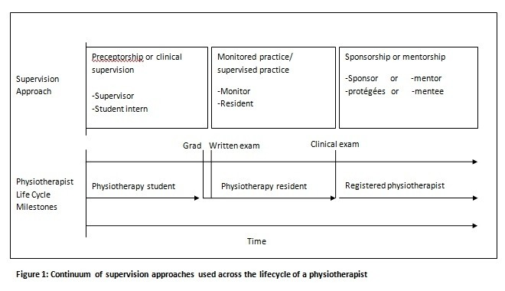

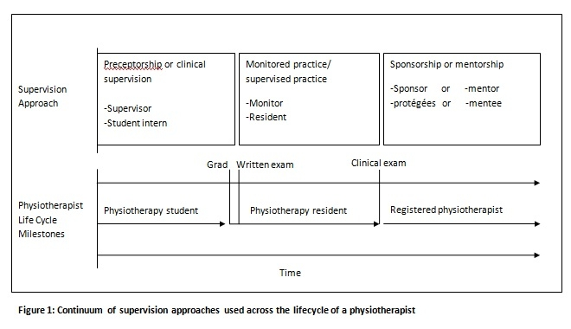

Duration of Supervision: The minimum and maximum requirements for supervision vary with the needs of the supervisee involved. At a minimum, the period of supervision should be set for as much time as is needed for the applicant to successfully complete the clinical component of the PCE. Applicants are encouraged whenever possible to take advantage of the entry to practice supervision opportunity while preparing for the clinical examination.

Selection/Training of Supervisors
Selection of Supervisors: The supervisee is responsible for identifying the supervisor or employer and securing agreement for the entry to practice supervision. The final approval of the supervisor and site rests with the regulatory authority.

Eligibility Criteria: Based on best practice, eligibility criteria for supervisors should include the following:
The supervising physiotherapists must:
- be registered and in good standing in the jurisdiction in which the supervisee is gaining the experience,
- hold an unrestricted license (e.g., not be subject to any fitness to practice proceedings or orders),
- have no significant past history with the College that would prevent him/her being a competent supervisor
- have no conflict of interest (e.g., no relationship to the candidate),
- have a minimum number of 3 years of experience in independent practice in Canada,
- be able to assess the quality of the work performed (e.g., be working in the same area of practice), and
- have the same employer as the supervisee.

Information/Training: Information about the supervision role will be provided by the local physiotherapy regulator. This information will describe the expectations of and assist in preparing the supervisors and supervisees for the supervised practice arrangement. An agreement or plan for the supervision period outlining the responsibilities of the supervisor and supervisee will be developed and signed by both parties and submitted to the regulatory authority at the outset of the period.

Supervision Approach and Responsibilities
Supervision Approach: The supervision approach in entry to practice situations must ensure safe delivery of physiotherapy services and the prevention of any undue risk of harm to the public. Since the supervisee has not yet been deemed competent to practice independently, it is the supervisor’s responsibility to monitor the activities of the supervisee using both direct and indirect methods of observation and to develop an appropriate supervision plan. It is also the responsibility of the supervisor to evaluate the supervisee within the first 30 days of the period of supervised practice. The specific methods and level of supervision will vary depending on the supervisor’s initial and ongoing assessments of the supervisee’s level of competency. Examples of methods of supervision include: direct observation, chart audits, meetings, case reviews, and feedback from peers and other team members. If a supervisee is unsuccessful in an attempt on the clinical component of the PCE, the supervisor should take this into account and adjust the supervision plan accordingly. In jurisdictions with restricted/authorized activities, supervisees may only perform activities they are authorized to perform and supervisors may only supervise activities that they are authorized to perform.

Responsibilities of the Supervisor: Since the supervisor is required to either indirectly or directly monitor the activities of the supervisee, the supervisor and supervisee will optimally have the same employer. The supervisor should be on site to indirectly or directly monitor the activities of the supervisee until the initial evaluation is competed. Afterwards, the supervisor is expected to consider the individual needs of the supervisee and provide the necessary level of supervision to ensure safe delivery of physiotherapy services and protection of the public. At this point, working with a delegate of the supervisor may be possible. Availability by telecommunication may also be considered in certain circumstances (e.g., supervisee has demonstrated good insight related to circumstances requiring supervisor input). Other responsibilities of the supervisor include: ensuring informed consent is obtained from the patient for involvement of supervisee; making arrangements for supervision when not available; ensuring employer comprehension and acceptance of professional obligations regarding supervision; notifying the regulatory authority of changes in supervisor; mandatory reporting of incompetence or misconduct; and completion and submission of evaluations as required. There may be multiple supervisors as long as one supervisor has primary responsibility.

Responsibilities of the Supervisee: The supervisee may be in either a part-time or full-time position. The supervisee is accountable for his/her actions and should have the same requirements for liability insurance as a full registrant. The supervisee is also responsible for notifying the regulatory authority of changes in supervision.

Evaluation/Monitoring
Evaluation Requirements: The supervisor must evaluate the supervisee within the first 30 days of the period of supervised practice to determine an appropriate level of supervision. Regulatory authorities and supervisors should consider arrangements for ongoing monitoring and a progress report given to the supervisee during longer periods of supervision so that the level of supervision can be adjusted accordingly. A final evaluation should be completed at the end of the period of supervision and sent to the regulatory authority.

Evaluation Tool: Whenever possible, an evaluation tool that has been determined to be valid and reliable for measuring entry level competence of physiotherapists should be utilized to evaluate supervisees in entry to practice supervision situations (e.g., Clinical Performance Instrument – CPI or equivalent).

Monitoring of Supervisee Evaluations by Regulatory Authority: The regulatory authority is responsible for monitoring the evaluations of supervisees that have been identified as having performance issues during the supervised practice or failure(s) on the examination. When possible, the regulatory authority should consider conducting random reviews of the final evaluations.

Formal Monitoring of Entry Level Supervision by the Regulatory Authority: Regulatory authorities should monitor their entry to practice supervision programs in terms of numbers of participants, performance issues during the supervision period, and any subsequent complaints. Analysis of pan-Canadian data from the individual regulatory authorities is desirable for educational and comparison purposes.

Review

This framework should be reviewed by the Registrars’ Committee a year after implementation and at regular intervals subsequent to implementation.

Some jurisdictions will likely exceed the practices set out in the framework, while others may not be able to fully meet them.
To be determined by each individual College.

